Days 32-33: Interactive Dynamic Analysis with ANY.RUN
// 32-33 OVERVIEW & SCOPE

This phase moved from static analysis to interactive dynamic analysis using ANY.RUN, a cloud-based sandbox that allows real-time interaction with an executing sample rather than a blind automated detonation. The goal was to observe process behavior, network activity, file system changes, and registry modifications for the malware samples collected during Day 31, using FakeNet to simulate network services and capture traffic even though the sample's original C2 infrastructure is no longer live.
Scope note: this session covered a single sample (cryptowall.bin, from the sample1 set) rather than both samples originally staged. The sample crashed almost immediately after execution, which limited the amount of dynamic behavior observed but still produced a usable, if narrow, set of findings and a clear negative result worth documenting.
// 01 LAB SETUP & SAMPLE STAGING

The NAT adapter on the Kali VM was temporarily re-enabled to allow the upload to ANY.RUN, per the requirement that this step be performed from inside the Kali VM browser rather than the host — uploading from the host risks the sample being altered or quarantined by host-side endpoint protection.
$ Sample Verification
Before upload, the sample was located and hashed to establish a verifiable baseline:
└─# ls ~/malware_samples/sample1/
cryptowall.bin.exe

└─# sha256sum ~/malware_samples/sample1/*
47363894c3e907e2b89f26c1be5115dc7 cryptowall.bin.exe
A file-picker permission issue ("Could not read the contents of root") was encountered when browsing to /root for the upload, caused by the browser's file dialog running under a sandboxed portal that cannot access the root home directory. This was resolved by staging a copy of the sample in /tmp/upload with open permissions and browsing to that path instead.
$ ANY.RUN Session Configuration
- Environment: Windows 10 64-bit, matching the sample's target architecture
- FakeNet: enabled prior to starting the session
- Detonation mode: manual — the sample was located on the sandbox desktop and double-clicked directly rather than relying on automated detonation
// 02 SAMPLE 1 — CRYPTOWALL.BIN EXECUTION

cryptowall.bin.exe was launched from C:\Users\admin\AppData\Local\Temp\cryptowall.bin.exe under the sandbox's admin user context at Medium integrity level, with no command-line arguments. Within roughly 2.7 seconds of execution, the process crashed, triggering a spawn of WerFault.exe — Windows' built-in crash-reporting process — rather than any injection or persistence behavior.
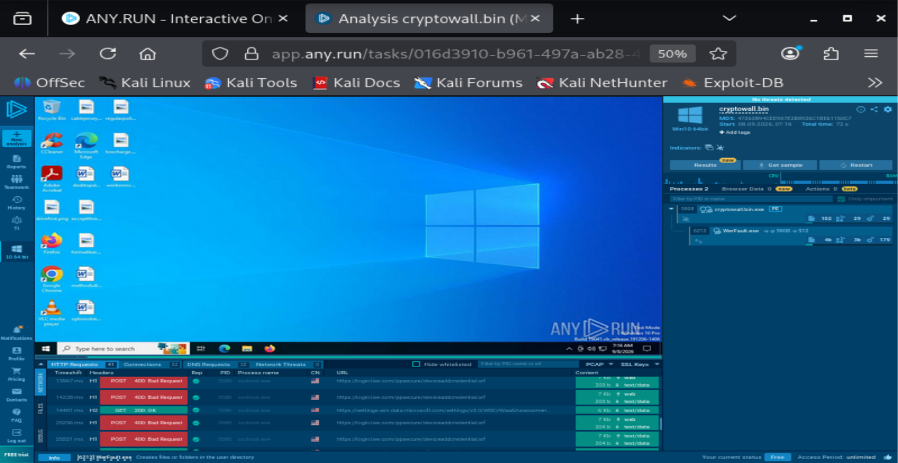
ANY.RUN session desktop showing cryptowall.bin.exe (PID 5908) and its WerFault.exe child (PID 6212), with network panel visible below
$ Process Tree
cryptowall.bin.exe [PID 5908]
Path: C:\Users\admin\AppData\Local\Temp\cryptowall.bin.exe
Command line: "C:\Users\admin\AppData\Local\Temp\cryptowall.bin.exe"
User: admin Integrity Level: MEDIUM
|
+-- WerFault.exe [PID 6212]
Path: C:\WINDOWS\SysWOW64\WerFault.exe
Command line: -u -p 5908 -s 512
Company: Microsoft Corporation (Windows Problem Reporting)
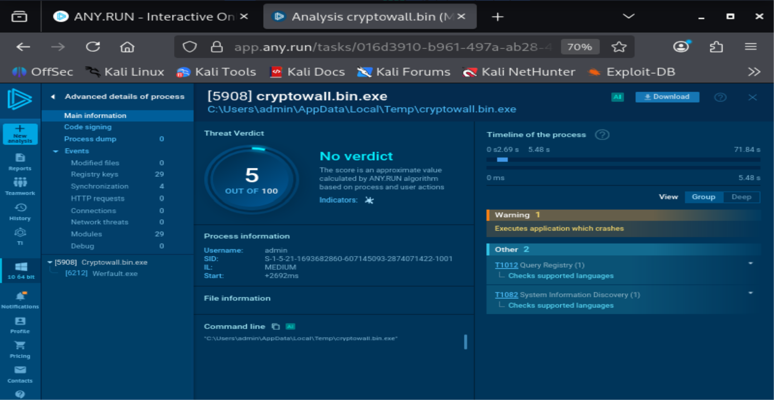
Advanced process details for cryptowall.bin.exe — threat score 5/100, no verdict, MITRE tags limited to T1012 (Query Registry) and T1082 (System Information Discovery)
$ Threat Verdict
ANY.RUN assigned a score of 5 out of 100 with no verdict. The only MITRE ATT&CK-tagged behaviors observed — T1012 (Query Registry) and T1082 (System Information Discovery) — were both scoped to "checks supported languages," which is standard environment/language fingerprinting rather than meaningful reconnaissance or persistence activity. The dominant event was a single Warning: "Executes application which crashes."
$ Network Activity — Reassessed as Environmental Artifact
Initial observation of the Network panel showed repeated POST requests to login.live.com/ppsecure/deviceidcredential.srf (returning 400 Bad Request via FakeNet) and a GET to settings-win.data.microsoft.com (200 OK). Drilling into per-process advanced details showed cryptowall.bin.exe itself logged zero HTTP requests and zero connections, while WerFault.exe logged 3 HTTP requests and 3 connections — confirming this traffic originated from Windows' own crash-reporting telemetry, not from the malware sample.
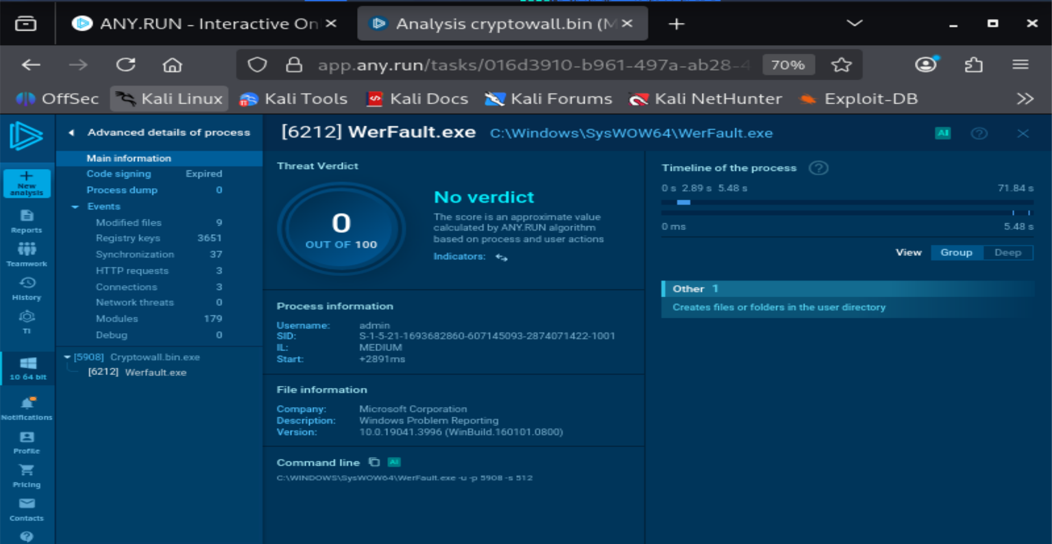
Advanced process details for WerFault.exe confirming it as the source of the observed network traffic — legitimate Microsoft Windows Error Reporting process with an expired code-signing certificate
This is recorded as a corrected finding rather than a discarded one: an analyst's first read of sandbox network traffic should not assume it belongs to the sample under test without confirming the source process. WerFault's code-signing certificate was flagged as Expired, which is common in older sandbox base images and not itself an indicator of compromise.
$ File System & Registry Activity
- cryptowall.bin.exe: 0 modified files logged against the process itself before it crashed
- WerFault.exe: 9 modified files and 3,651 registry key reads — consistent with standard Windows crash-dump and error-reporting behavior, not malware persistence
- No writes to Run keys or other persistence locations were observed from either process
- No files were dropped into Startup folders or system directories by the sample

// 03 FINDINGS SUMMARY

The sample crashed almost immediately after launch and did not exhibit meaningful dynamic behavior — no persistence, no injection, no C2 communication of its own. The traffic that initially looked like credential/telemetry exfiltration to Microsoft-branded endpoints was traced to the sandbox's own WerFault crash handler rather than the sample. This is a legitimate negative result: it indicates the sample is either non-functional in this sandbox environment, missing a dependency, or built for a different OS/architecture than the one provided, and is documented as such rather than discarded.
Given the crash-on-launch behavior, the second sample was not analyzed in this session; scope was narrowed to a single-sample dynamic analysis pass.
// 04 IOC TABLE

Indicator Type | Indicator Value | Phase | Significance
File Hash | 4736389...4c1be5115dc7 (SHA-256) | Dynamic | Unique identifier for cryptowall.bin.exe, the analyzed sample
File Path | C:\Users\admin\AppData\Local\Temp\cryptowall.bin.exe | Dynamic | Execution/drop location; not a persistence path
Process Behavior | cryptowall.bin.exe crashes ~2.7s post-launch (Warning: Executes application which crashes) | Dynamic | Indicates a non-functional or environment-mismatched sample rather than a live payload
False-Positive Note | login.live.com/ppsecure/deviceidcredential.srf, settings-win.data.microsoft.com traffic | Dynamic | Attributed to WerFault.exe (legitimate Windows crash reporting), not the sample — recorded to prevent misclassification, not as a true IOC
// 05 DELIVERABLES

- Screenshots: session desktop/process view, cryptowall.bin.exe advanced details, WerFault.exe advanced details (embedded above with captions)
- Process tree document: cryptowall.bin.exe (PID 5908) → WerFault.exe (PID 6212), included above
- IOC table: covering the single analyzed sample, included above
- PCAP and full ANY.RUN report: to be exported from the session and saved as sample1_capture.pcap / sample1_report.pdf
- Public share link: to be generated from the ANY.RUN task once finalized and added to this report

